Open Putty and put IP address of the CentOS VM in Hostname and select SSH for the connection type. Refer below image. (Attach Screenshot)
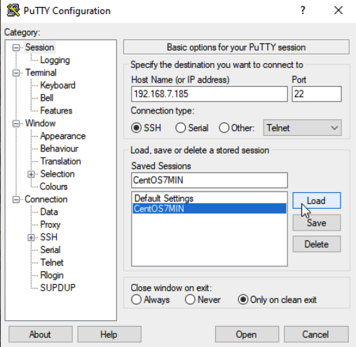

You’ve now successfully logged in into your CentOS VM using PuTTY (SSH).
(Attach Screenshot)
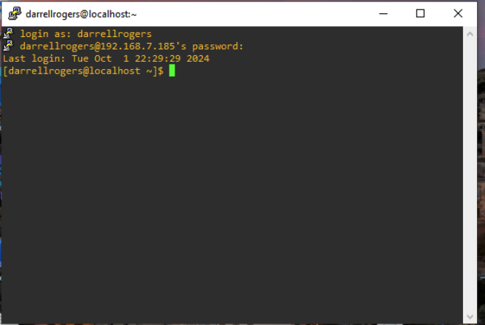

Run the simple Code. (Attach Screenshot)
Code: print(“Hello FistnameLastname”)
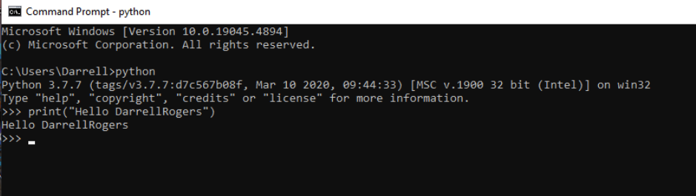
Part 4: Practice

- Try text editor options you like and make a decision which text editor you plan to use moving forward in your Linux environment. Report your decision and insert a screen shot of your text editing environment.

For text editing I use several options. I am required to create design drawings in both Visio and Miro at Ford. Each has its own benefits. Miro allows me to use “url” inserts to simply drop text into the file. In this case I use Microsoft OneNote extensively. This allows me to organize my thought with tabs. When I am developing code my text editor of choice is Microsoft Visual Studio Code with its many plugins. It is more of a file explorer but with the additional plugins it makes writing code very easy.
If I am simply on a Windows Machine and only need a place to take notes I will default to Notepad++. This product does not have a MAC version, so I rarely use it anymore.
If I am on a MAC or Linux OS and I am doing very light editing on the fly I will use VI as an editor. BASH is the only place where I use grep and usually only when searching for files or directories.
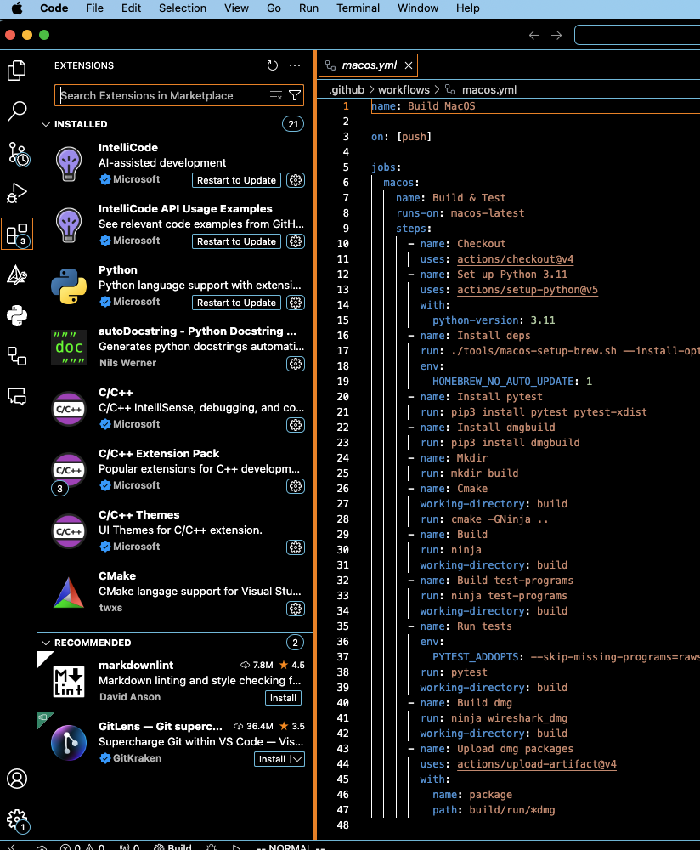
Create a sample text with your text editor and try at least 5 regular expressions with $grep command and include screen shots of the results.
  - e.g. $ grep “expression” filename
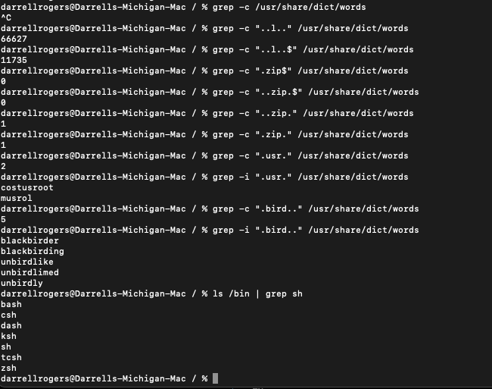
- Use crontab –e to schedule the job to record the date at every minute in a file in your home directory. After 10 minutes of running, include a screen shot of the file.
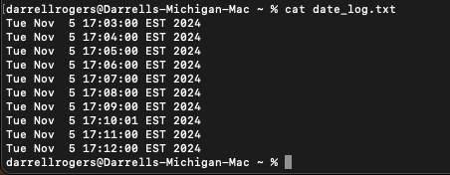

- Practice various performance tools (iostat, vmstat, etc.) on your Linux system and include only 2 screen shots of your choosing from these tools.
